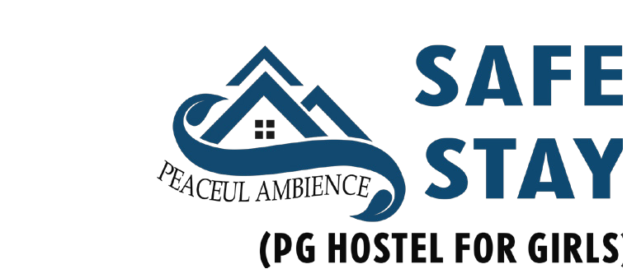HOSTEL ADMISSION
FORM

SAFE STAY: PG HOSTEL FOR GIRLS Koira Shangpung, West Jaintia Hills Meghalaya - 793150

Application No. Academic Year

NAME OF THE STUDENT :
(In Block Letters)

Affix your your
Date of Birth: DD MM Year passport size
photograph here
Age: Years Class:

Birth Place : State : Nationality : Religion :

Mother Tongue : Blood Group : Residential Address :
Pin Code : Correspondence Address :

Pin Code :

Mobile No. : E-mail :

Emergency Contact No. (Res/Mobile) Name of the Person to be contacted Relationship

Whether the candidate had stayed in any hostel before: Yes/No

Whether the candidate has any medical historyof ailments: Yes/No
(If yes, please state briefly and attach medical certificates)

DECLARATION BY THE STUDENT

01. I , have read the rules and regulations for my ad- mission into accommodation facilities of Safe Stay, Hostel.
02. I agree to speak at any cause only English Language and I agree to be liable for penalties and punishments for breaking the rule of language.

03. I agree not to indulge in groupism of any type and would live in harmony with others in the hostel.

04. I understand that smoking and consumption of alcohol and other objectionable material in the hostels is strictly prohibited and I will abstain from such acts.

05. I declare that indulgence in any anti-instutional or anti-social activity in the hostel is highly punishable and I
will be liable for severe penalties and punishments for indulging in such acts.

06. I declare that I am physically and medically t to live in the hostel. I also declare that every information about my being medically / psychologically unto in any degree or manner has been bought to the information of the authorities at the time of applying for hostel accommodation. I will not hold the management, school authorities, or the hostel authorities responsible for any consequence which will be a result of my non-disclosure.

07. I undertake to conduct myself as a diligent student within the hostel and in the vicinity and not misbehave in any manner including using inappropriate language, physical tiffs with the other inmates / employes / and others in the hostel’s neighbourhood.

08. I will abide by the rules that prohibit use of mobile phones in the hostel premises.

09. I agree not to cook, not to use electric and electronic gadgets, not to wash and press clothes in the hostel rooms.

10. I will not cause any damage whatsoever, including defacing to the property of the hostels and understand that
I will be liable for penalties and punishments for doing so.

11. I accept to stay within the hostel premises by the stipulated time and will not stay out without proper prior permission from concerned authorities.

12. I undertake to abide by all the rules that govern my stay in the hostel and also all the changes to the rules that may be made from time to time.

13. I will not damage any furniture or appearance of room and will agree to pay the ne if done so.

14. Finally, I agree to abide by all the rules and regulations of the institution with regard to hostel stay, which may be framed from time to time and accept the decision of the management in all respects as nal and binding on me for compliance.

Place : Date :

Signature of the student

DECLARATION BY PARENT/GUARDIAN

I assure that my ward will abide by the rules and regulations of the Hostel. I have no objection if my ward is ex- pelled from the Hostel for violating the rules.

Place: Date:

Signature of the Parent/Guardian

